SOLANO COMMUNITY COLLEGE
MT 164, PROGRAMMABLE LOGIC CONTROLLERS
Spring, 2018

INTRO TO PLC PROGRAMMING LAB
Catharine Crayne
2/4/2018

OBJECTIVE
- To write a PLC Program, wire it, and run it.

GROUP MEMBERS

MATERIALS & EQUIPMENT
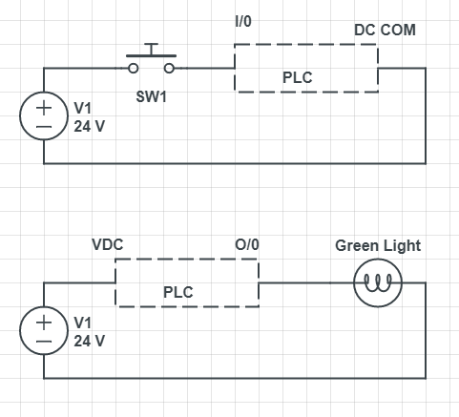
Micrologix 1100 Trainer Unit, wires, RSLinx and RSLogix software, laptop, crossover ethernet cable.

PROCEDURE:
- Wire up a push-button switch and light to the PLC and the distribution blocks on the trainer. Use the diagram to the right as a guide.
- Write a simple ladder logic program that uses that switch to turn on the light. Save it or screenshot it to use in your lab write up.
- Download that program into the Micrologix PLC.
- Verify the program works.
- Now change the program so that it turns on the light when the switch is open instead. Save or screenshot this.
- Download that program and verify that it works.
- Now wire up another light to a different PLC output.
- Modify the program so that the switch turns on one light when normally open and another light when normally closed. Save or screenshot this program.
- Download that program and verify that it works.

RESULTS - DATA

Step 2: Snapshot of our program.
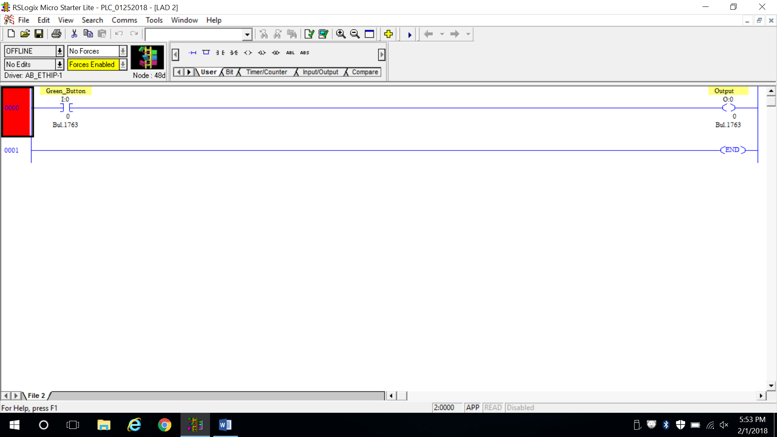

Step 5: Snapshot of our program.
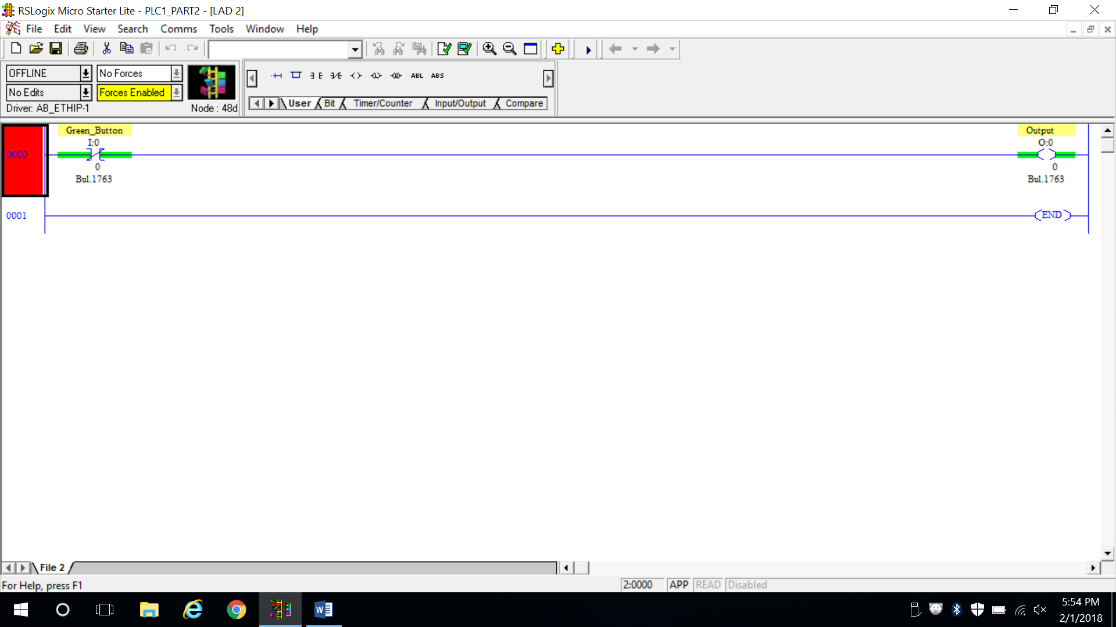

Step 8: Snapshot of our program.
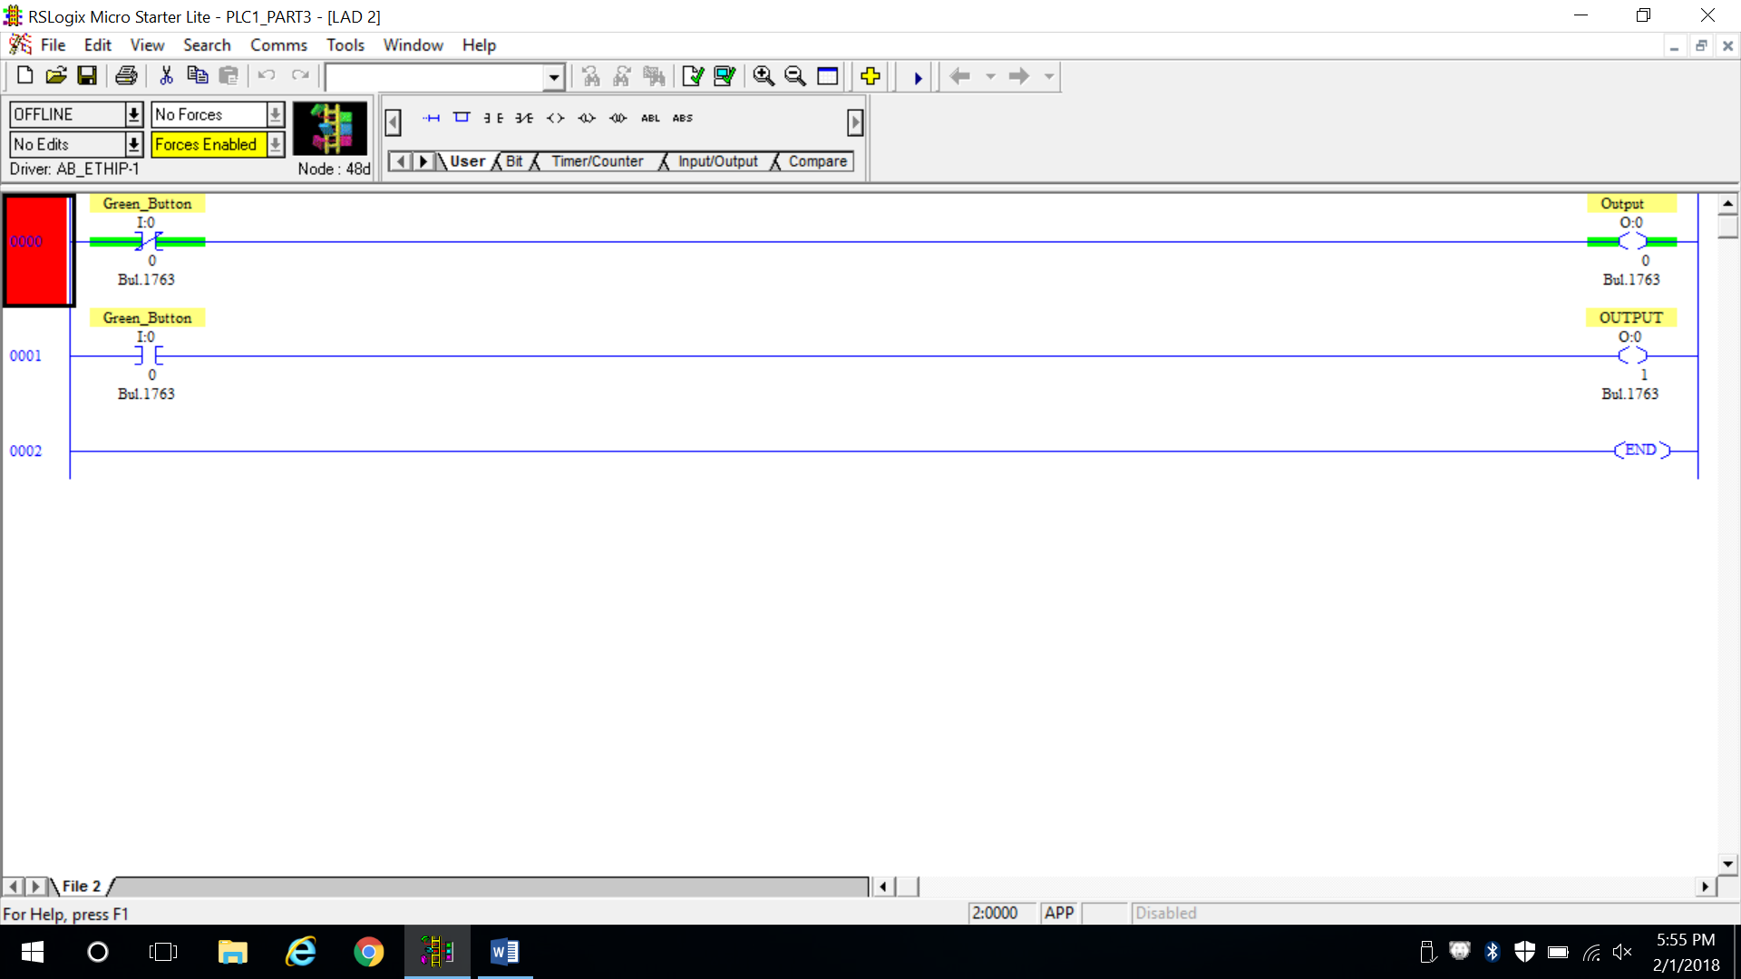

OBSERVATIONS

Step 1: Picture of our setup Step 6: Picture of our setup
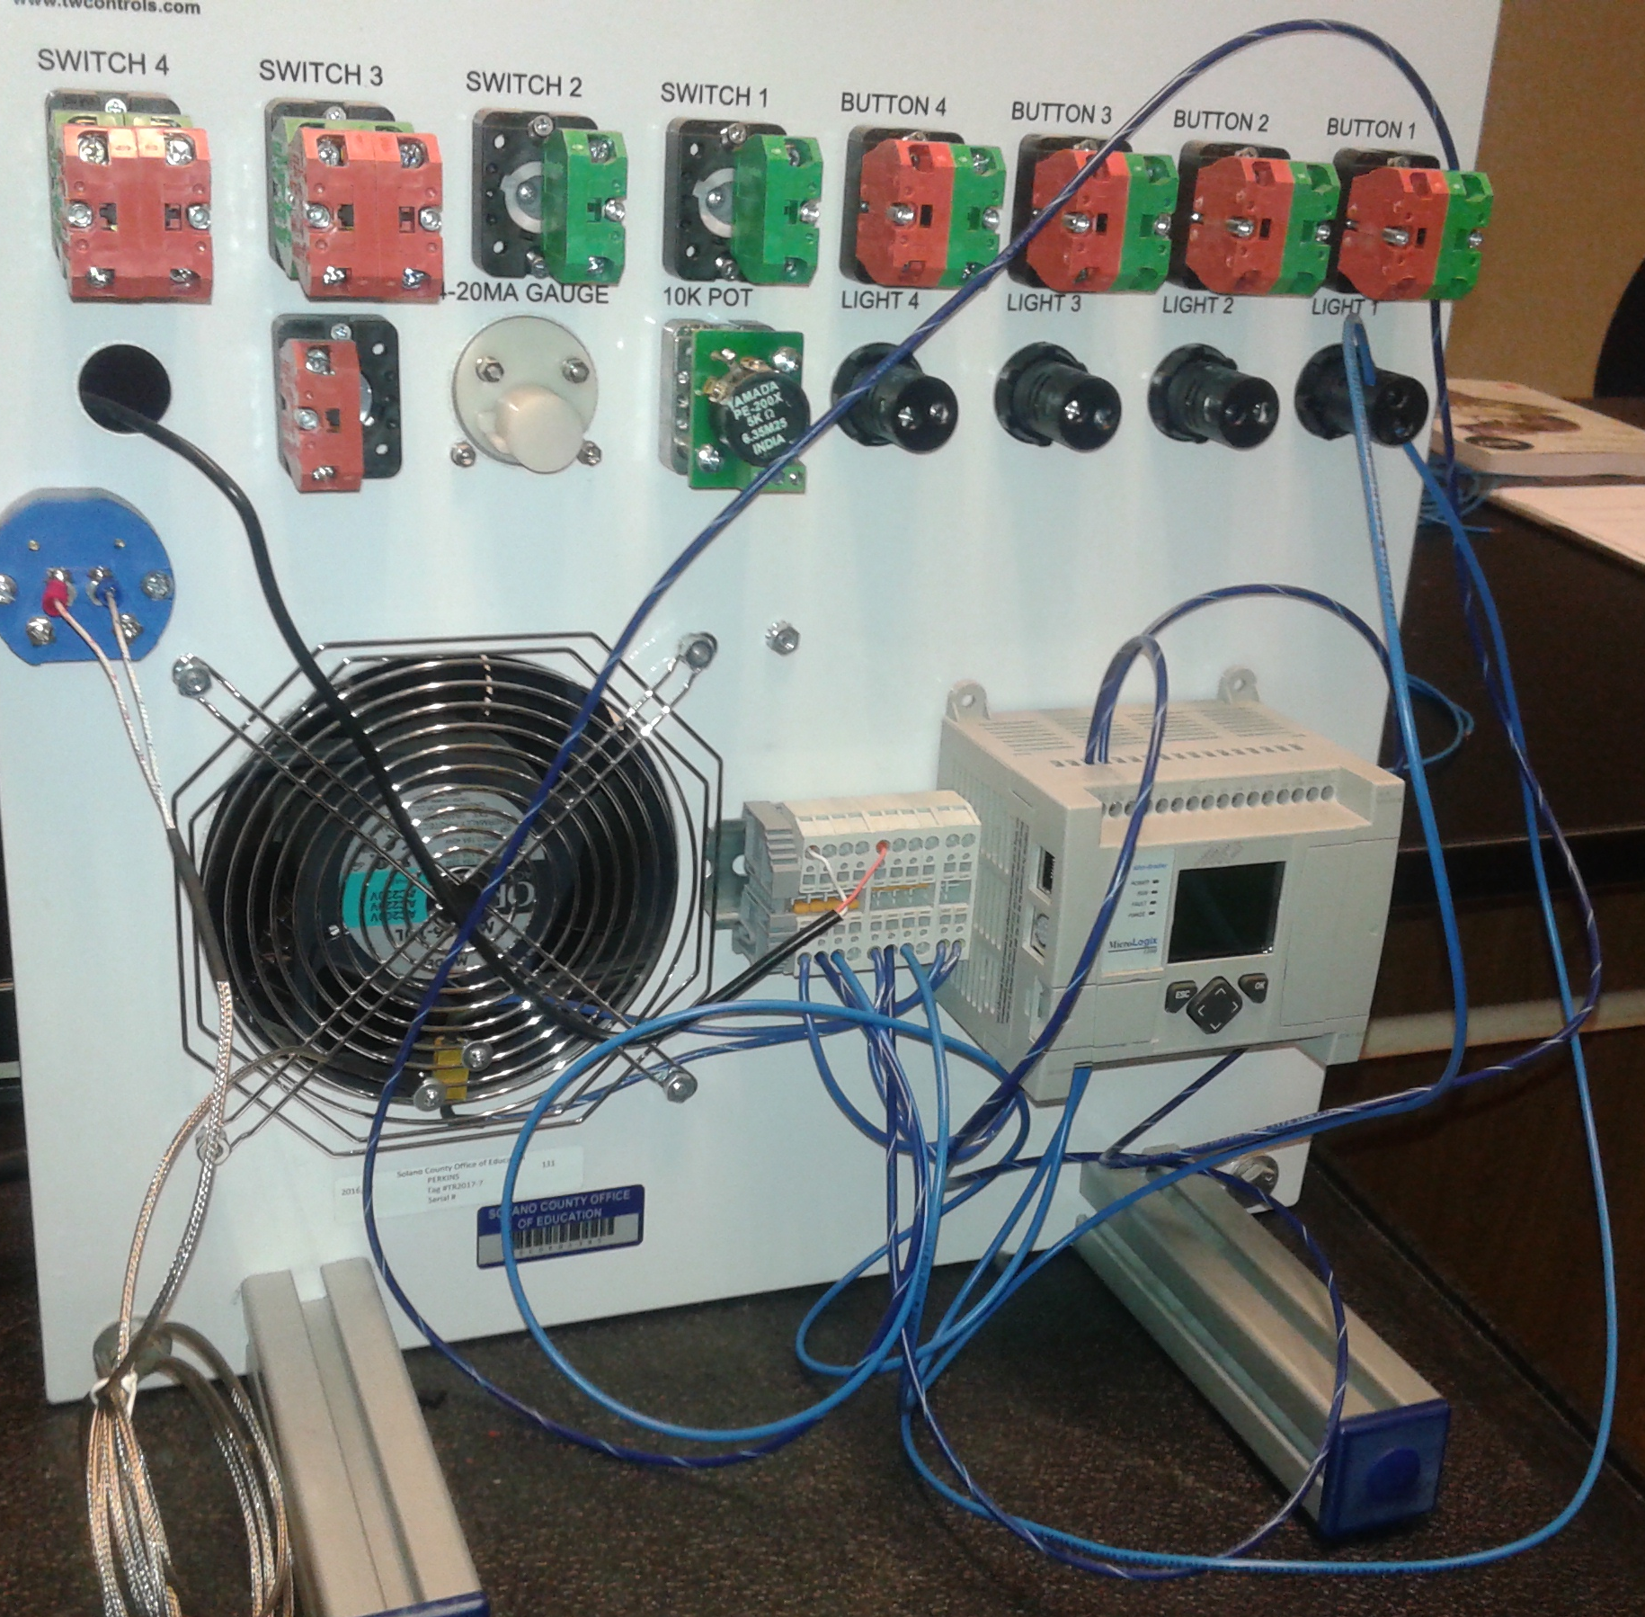
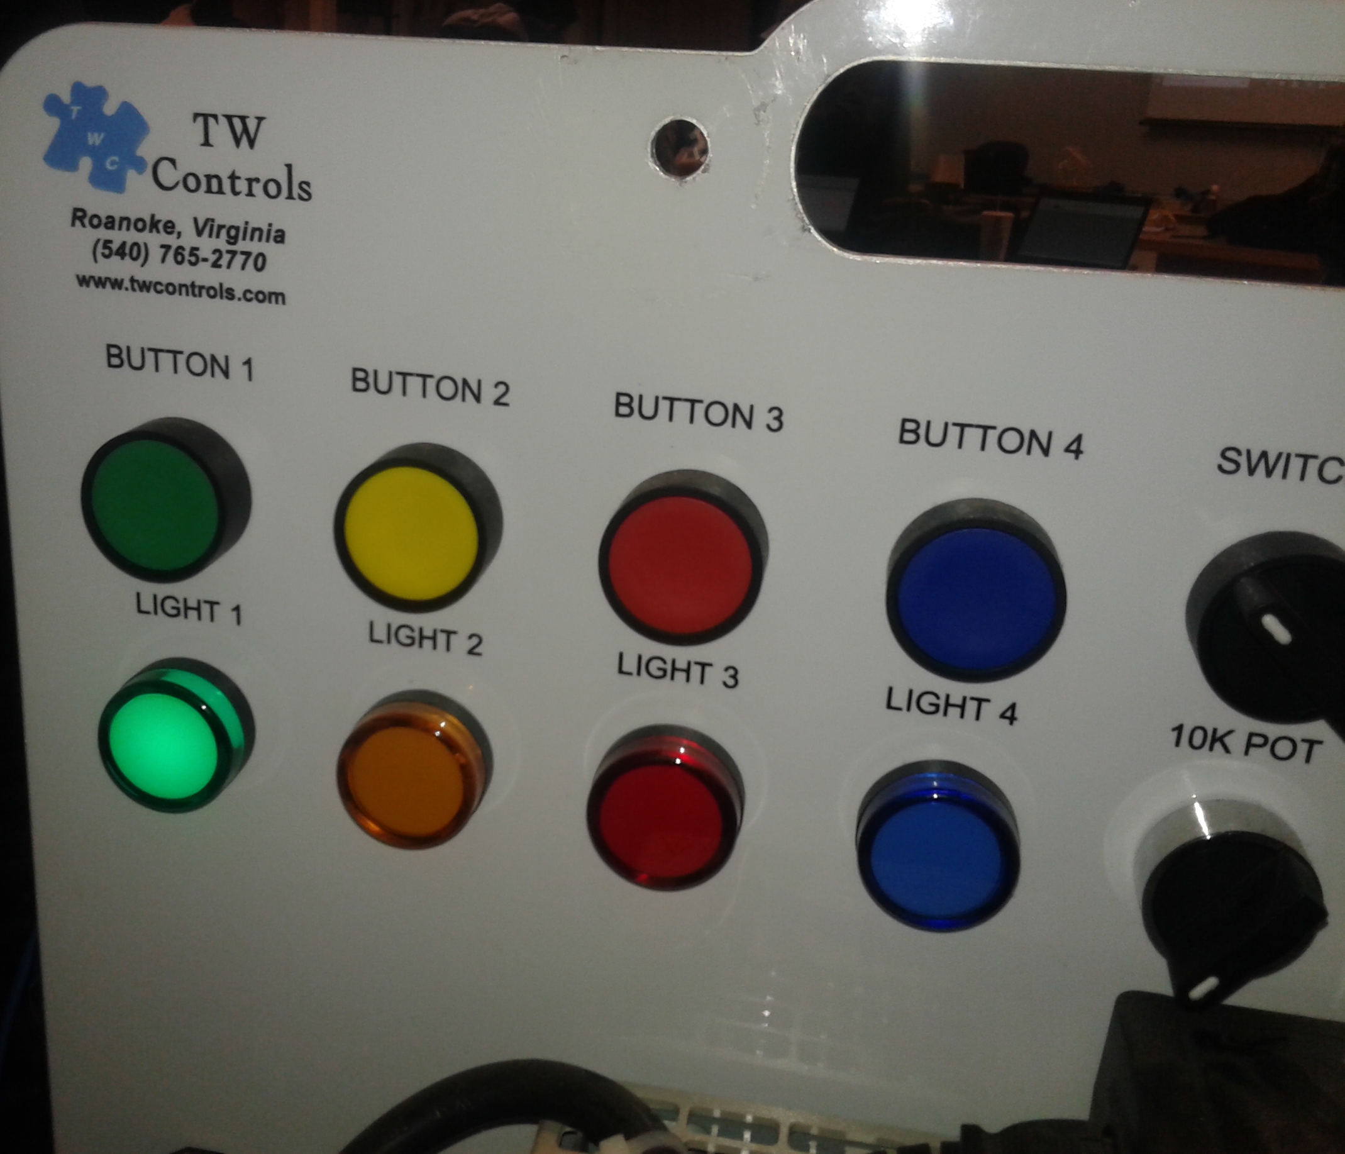

Step 9: Picture of our setup
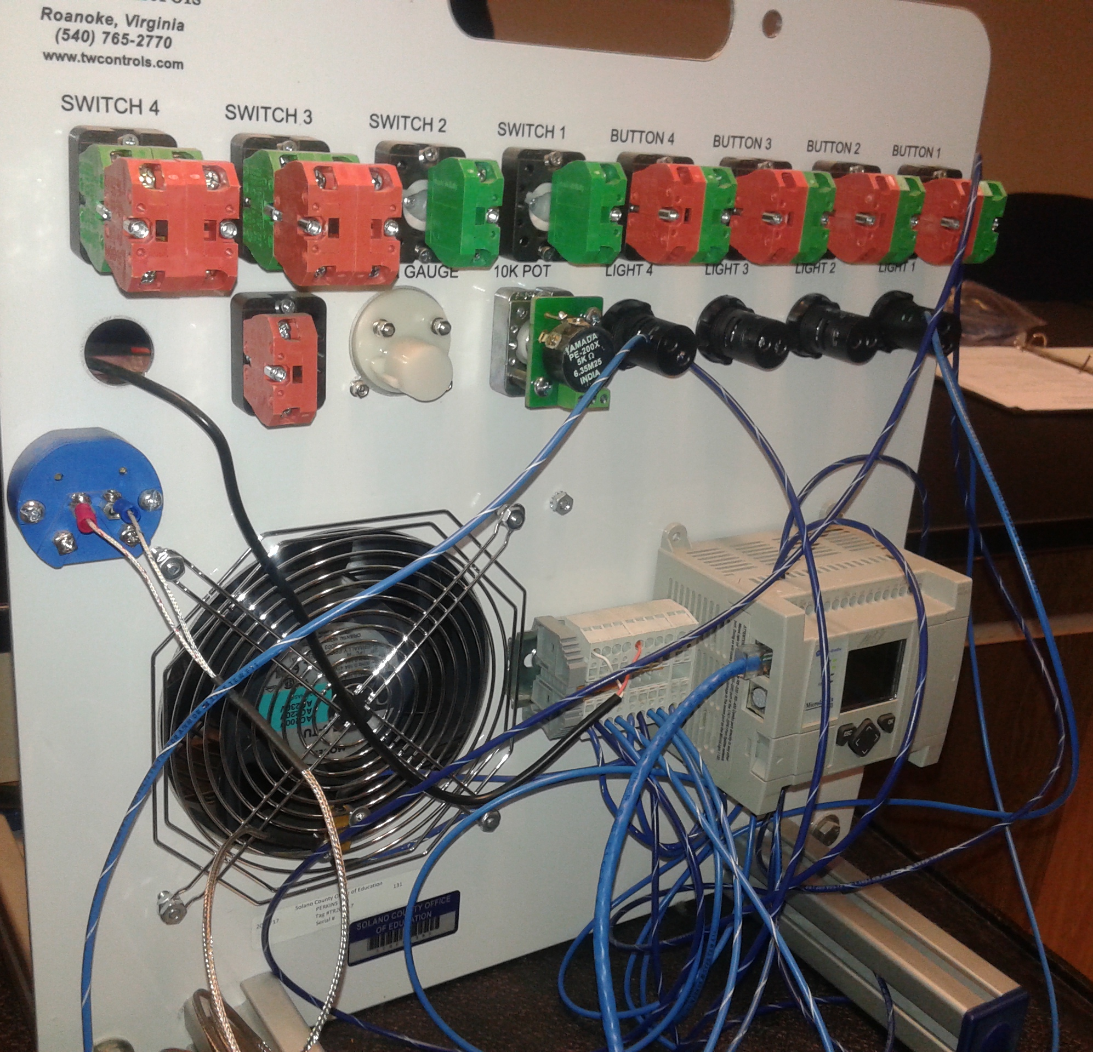

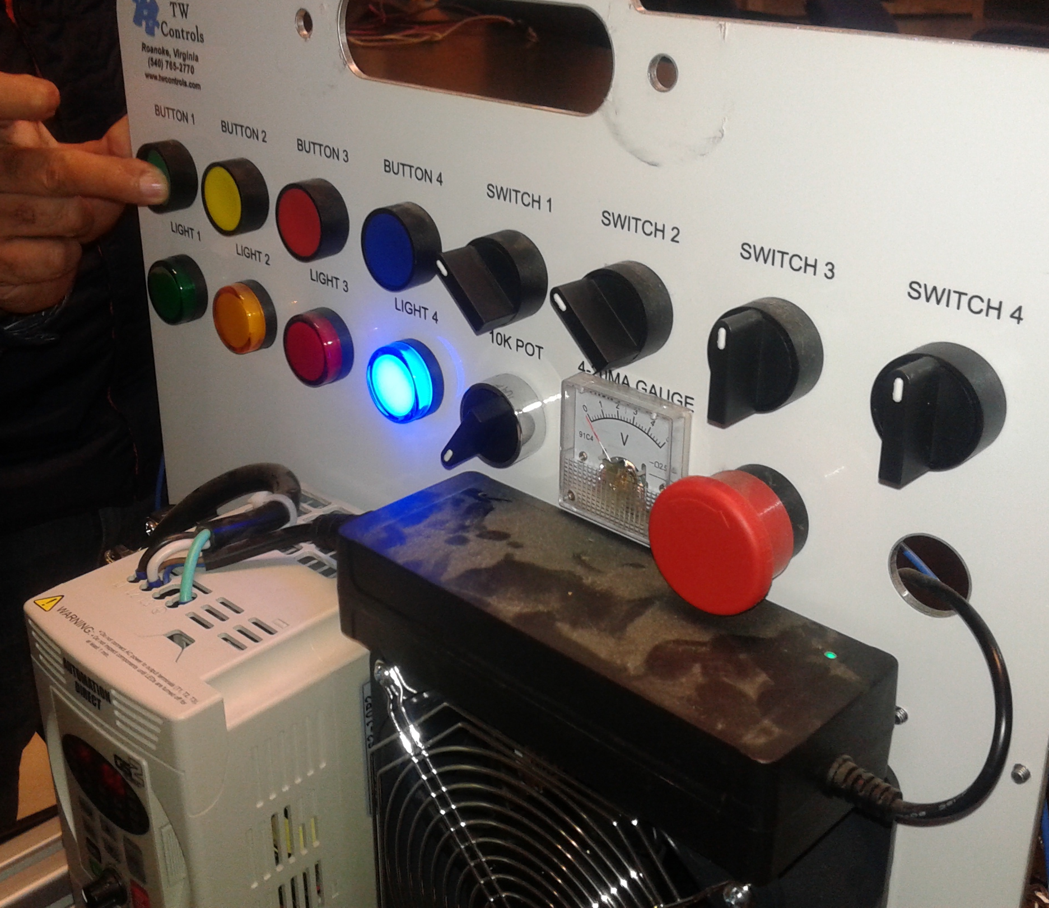

ANALYSIS QUESTIONS:
- What is mean by ladder logic abbreviations… XIO, XIC, and OTE?
XIO = Examine if open. This is an instruction to the processor to examine the contact if it is open. An XIO looks and operates like a normally closed relay contact.
XIC = Examine if closed. This is an instruction to the processor to examine if the contact is closed. An XIC looks abd operates like a normally open relay contact.
OTE = Output Energize. This instruction signals the PLC to energize (switch on) or de-energize (switch off) the output. The OTE instruction looks and operates like a relay coil and is associated with a memory bit.
- Following the example in Figure 1-20 of the text, draw a schematic showing the wiring and program of each of the three circuits.
24VAC
L1
I/0
O/0
PB Switch
Red Light
I/0

24VAC
L1
I/0
O/0
PB Switch
Red Light
I/0

24VAC
L1
I/0
O/0
PB Switch
Blue Light
I/0
I/0
I/0
O/1
PB Switch
Red Light

